# Stackup Build More Things (BMT) Workshop

**Title**: Developing Flutter App on top of Facebook Libra Blockchain

**Abstract**:

Nearly 1.7 billion people globally remain outside the financial system, but billions of people nowadays have a mobile phone and a facebook account. Is Facebook Libra going to be the unbank solution for a long overdue problem?

There is an excellent excitement over blockchain and Facebook Libra in particular. Imagine transferring money via Whatsapp and Facebook messenger, sponsor events and campaign using Libracoin via Instagram and buying/selling stuff on the Facebook marketplace using Libra coin.

Even Singapore PM Lee did mention Libra on his Facebook’s wall.

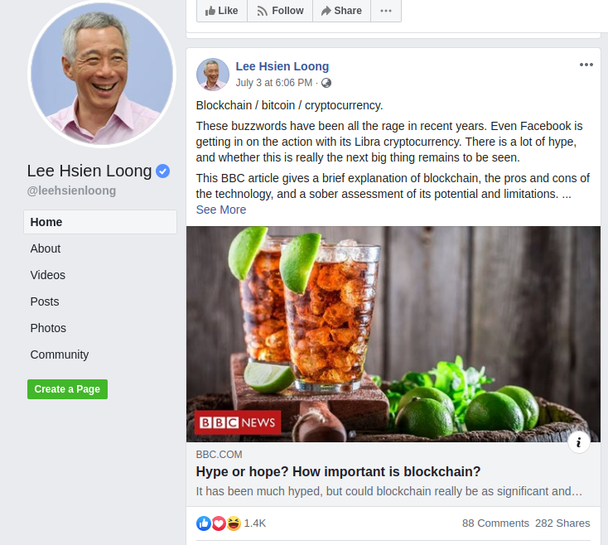

**What is Facebook Libra?**

It’s Facebook’s new cryptocurrency. The point is that you can send money all over the world with lower fees than if you were to engage, say, Western Union/Remittance shop.

Libra cryptocurrency is a stable coin, any cryptocurrency pegged with any fiat currency (say, e.g. SGD) or some security (like a bond) counts as a stable coin.

**Which consensus model Facebook Libra uses and what is so different compared to other Blockchain?**

Libra Byzantine Fault Tolerance, improved version Hotstuff Algorithm**.** Is permission scalable blockchain, meaning only a few trusted entities can keep track of the ledger. LibraBFT processes are called Validators and they make progress in rounds, each having a designated validator called a *leader*. Leaders are responsible for proposing new blocks and obtaining signed votes from the validators on their proposals. LibraBFT follows the Chained HotStuff model

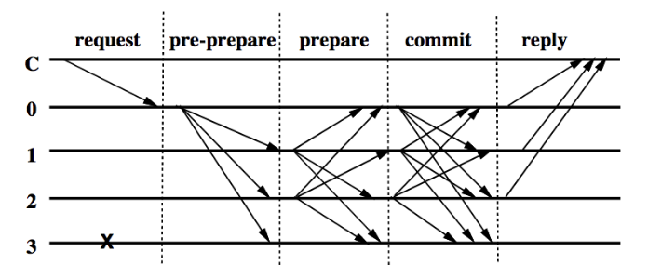

<https://www.theblockcrypto.com/2019/06/19/a-technical-perspective-on-facebooks-librabft-consensus-algorithm/>

<https://medium.com/ontologynetwork/hotstuff-the-consensus-protocol-behind-facebooks-librabft-a5503680b151>

<https://pdfs.semanticscholar.org/feee/8ffe4840af08978c767ec12c6ddeef782199.pdf?_ga=2.254341582.735251117.1562572896-1885490578.1562572896>

**What is a Move transaction scripts?**

Every transaction submitted to the Libra Blockchain uses a transaction script written in Move Programming Language (DSL) to encode its logic. The transaction script can call procedures declared by a module to update the global state of the blockchain.

In this introductory Facebook Libra workshop, you will

learn about

* Blockchain and Libra development tools, libraries and resources
* Use Move Language to write Transaction scripts and modules
* Interact with Facebook Libra gRPC stubs to submit an view transaction on the Libra’s blockchain network (Written in NodeJS)
* Interact with your transaction from a simple web application (Written in ReactJS)

If you are an aspiring blockchain developer, coder or just merely curious about Facebook Libra, this workshop is an excellent opportunity for you to learn about this exciting new technology.

Join this workshop. Seats are limited.

**Date**: Tuesday, August 13 2018

**Time**: 0900 — 1700

**Where**: #02-09, 79 Ayer Rajah Crescent, Block 79, Singapore 139955

**Cost**: **????**

**Prerequisite**: Should have a basic programming knowledge

**What to bring**: Notebook running either Windows, Mac or Linux (Ubuntu Preferred)

**Pre-workshop Setup**:

It is important that you have performed the following before coming to the workshop

Install Chrome browser

[https://www.google.com/chrome](https://www.google.com/chrome/)

Download & Install Git for Linux/Mac

<https://git-scm.com/download/linux>

<https://git-scm.com/download/mac>

Setup and try the tutorial ReactJS

<https://reactjs.org/tutorial/tutorial.html>

Download & Install NodeJS for Linux/Mac/Windows

Required : Node ^v12.0.0

<https://nodejs.org/en/download/>

Download & Install Visual Studio Code with Dart/Flutter /NodeJS Plugin <https://code.visualstudio.com/download>

Student’s computer should able to access

<https://developers.libra.org/docs/my-first-transaction>